Project Design Phase-II
Data Flow Diagram & User Stories
Date | 08 October 2026
Team ID
Project Name | Implement Client Script & UI Policy
Maximum Marks | 4 Marks

Data Flow Diagrams:
A Data Flow Diagram (DFD) is a traditional visual representation of the information flows within a system. It shows how data enters and leaves the system, what changes the information, and where data is stored. The DFD below shows how data flows between the user, the client-side logic (Client Scripts and UI Policies), the server and the database.
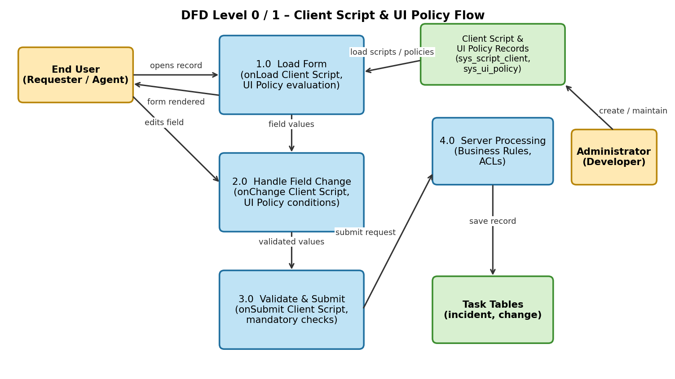
Data flow description:
1. The end user opens an Incident record; the platform loads the active Client Scripts and UI Policies for the form (Process 1.0).
2. When the user changes a field, onChange Client Scripts and UI Policy conditions run and update other fields, visibility or mandatory state (Process 2.0).
3. When the user clicks Submit / Save, onSubmit Client Scripts and mandatory checks validate the data (Process 3.0).
4. Valid data is sent to the server, where Business Rules and ACLs run, and the record is stored in the task table (Process 4.0).
5. The administrator creates and maintains Client Scripts and UI Policies, which are stored as records (sys_script_client, sys_ui_policy).
User Stories
Use the below template to list all the user stories for the product.
User Type | Functional Requirement (Epic) | User Story Number | User Story / Task | Acceptance criteria | Priority | Release
Administrator / Developer | Client Script – onLoad | USN-1 | As an administrator, I can create an onLoad client script so that default values are set when the Incident form opens. | Form opens with default values populated | High | Sprint-1
 | Client Script – onChange | USN-2 | As an administrator, I can create an onChange client script on Impact and Urgency so that Priority is recalculated and shown instantly. | Priority updates without saving the form | High | Sprint-1
 |  | USN-3 | As an administrator, I can use GlideAjax in an onChange script to fetch details of the selected Caller from the server. | Caller’s department / location auto-populates | Medium | Sprint-2
 | Client Script – onSubmit | USN-4 | As an administrator, I can create an onSubmit client script that blocks saving when Short description is shorter than 10 characters. | Error message is shown and record is not saved | High | Sprint-1
 | UI Policy | USN-5 | As an administrator, I can create a UI policy that makes Configuration Item mandatory when Category is Hardware. | Field shows mandatory asterisk and save is blocked if empty | High | Sprint-1
 |  | USN-6 | As an administrator, I can create a UI policy that makes Close notes visible and mandatory when State is Resolved. | Close notes appears only when State = Resolved | High | Sprint-1
 |  | USN-7 | As an administrator, I can create a UI policy that makes fields read-only after the incident is Closed. | All listed fields are read-only on Closed incidents | Medium | Sprint-2
 |  | USN-8 | As an administrator, I can use UI policy scripts (Execute if true / false) for advanced behaviour. | Script runs when condition is met and reverses otherwise | Low | Sprint-2
 | Testing & Deployment | USN-9 | As an administrator, I can capture all scripts and policies in an Update Set and move it to another instance. | Update Set commits successfully on target instance | Medium | Sprint-2
Customer (End user / Caller) | Incident Form | USN-10 | As an end user, I see only relevant fields on the incident form so that raising a ticket is simple. | Irrelevant fields are hidden based on selections | High | Sprint-1
 |  | USN-11 | As an end user, I get a clear error message when I miss required information so that I can correct it quickly. | Message names the field and the issue | High | Sprint-1
Customer Care Executive (Agent) | Incident Handling | USN-12 | As an agent, I see Priority and mandatory fields update automatically so that I spend less time on data entry. | Agent can resolve ticket with no manual priority calculation | Medium | Sprint-2
Administrator (ServiceNow Admin) | Governance | USN-13 | As a ServiceNow admin, I can review and enable/disable scripts and policies so that form behaviour stays under control. | Active flag toggles behaviour immediately | Low | Sprint-3

